Are you aware of climate change?



**Citizens For Our**

**Children’s Future**

Climate change refers to any long-term change in Earth's climate, or in the climate of a region or city. This includes warming, cooling and changes besides temperature. Climate change, once considered an issue for a distant future, has moved firmly into the preset.

Climate change has awful impacts on senior citizens:

* **Heatwaves** are direct result of global warming and it can cause severe heat strokes and dehydration in the elderly.
* Older adults are more susceptible and less likely to make a full recovery from **newer and more dangerous forms of animal, air and water borne diseases** due to climate change.

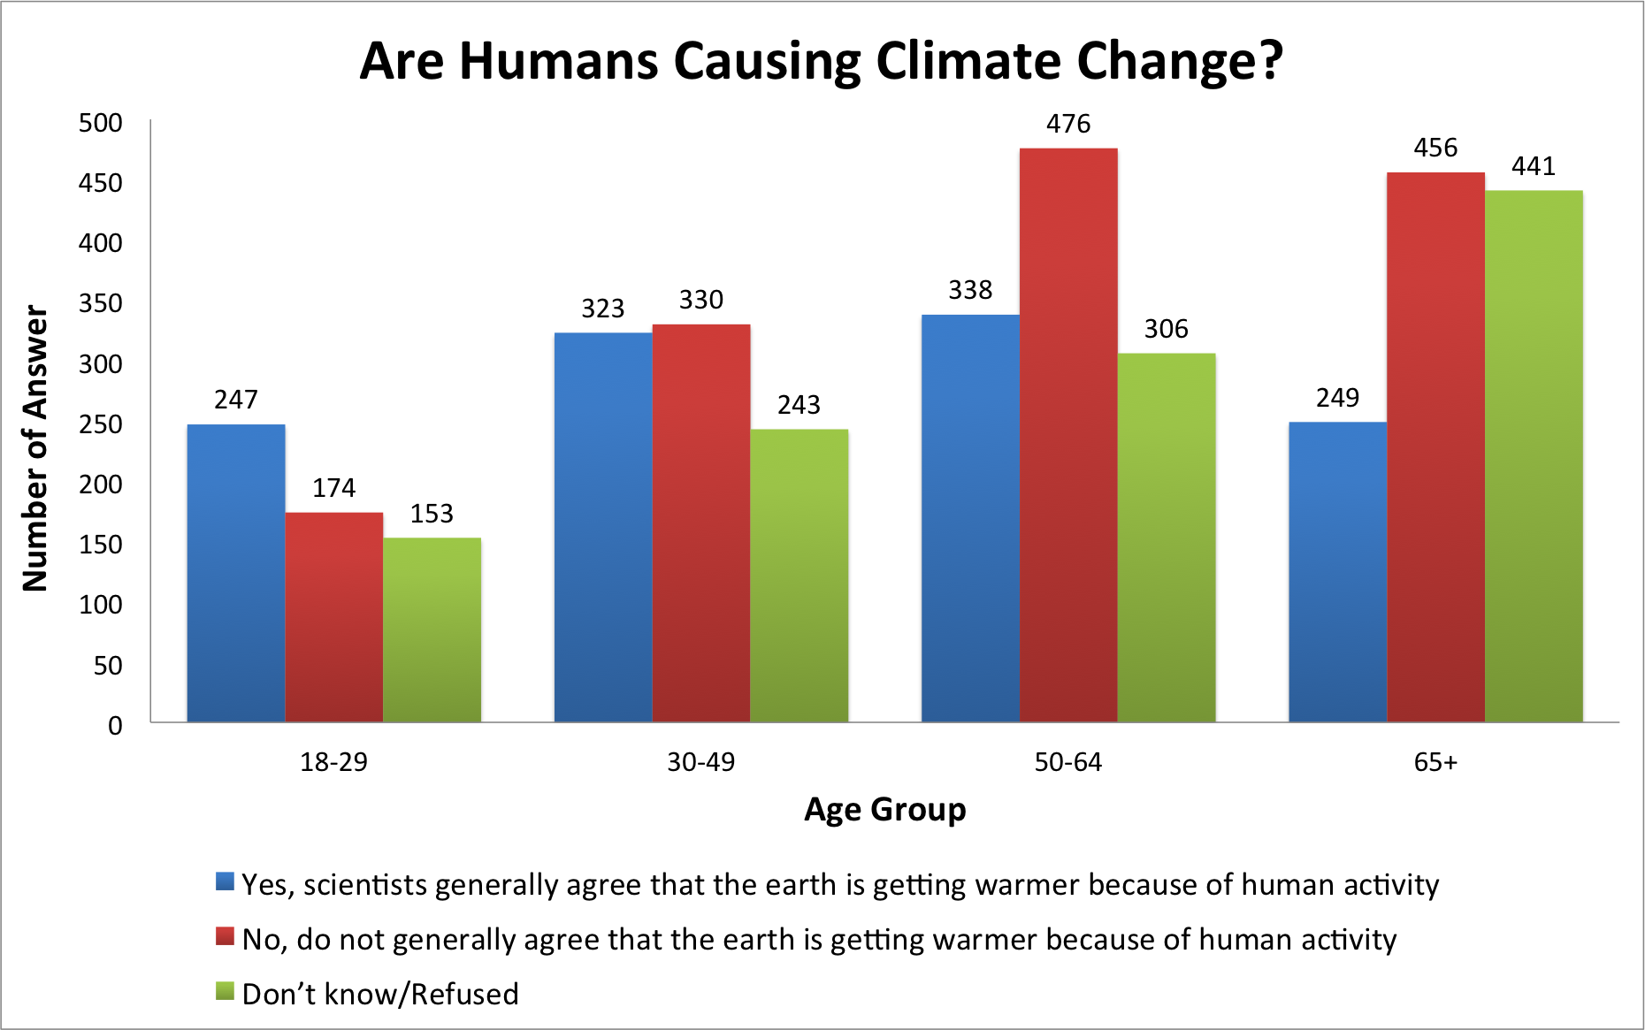

Pew research center’s general public science survey displayed that adults of 30+ ages are less likely to believe that the climate change is cause by humans. This result is scary because if they do not believe that humans cause the climate change, then they are less likely to make an effort to help fight against it.

You can partner up with Chicago Climate Action Plan and enroll in their programs to help make this world a safer place to live in. Visit our website at **www.cfocf.org** to learn more about climate change and step by step tutorials on how to get involved with Chicago Climate Action Plan, as well as how to find your state representatives and register to vote.